COMPUTER ORGANIZATION AND ASSEMBLY LANGUAGE

TOPIC:
INPUTS AND OUTPUTS

NAME:
MUHAMMAD TALHA
ROLL NUMBER:
241890
SECTION:
4/A

INSTRUCTOR:
MS ROMANA MAROOF

QUESTION#1
Program
a) Accept a single character input from the user and store it in a variable.
b) Display a custom message along with the user input.
c) Add a message that confirms the end of the program
ANSWER:
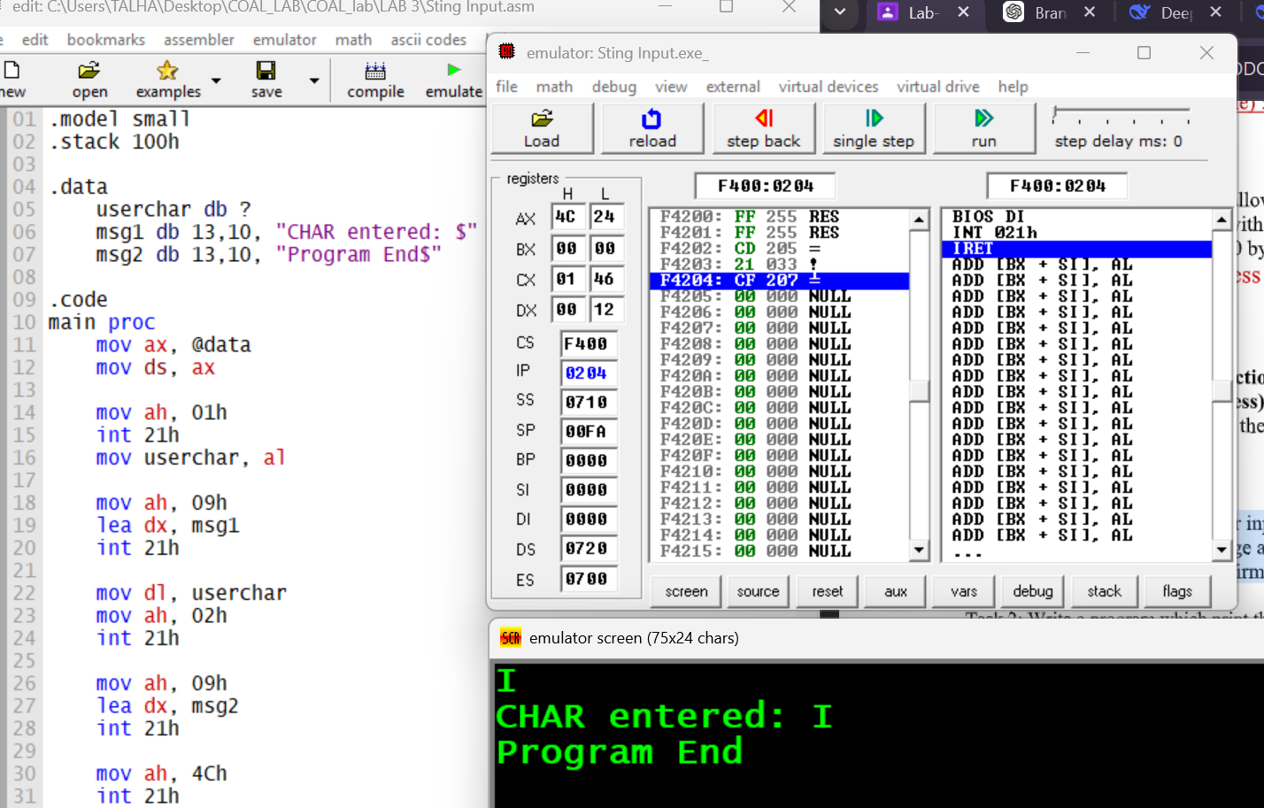
STEPS:
- Set program memory type.
- Reserve space for stack.
- Declare variables and messages.
- Prepare data segment.
- Activate data segment.
- Read a character from the user.
- Store the entered character.
- Display the first message.
- Display the entered character.
- Display the end message.
- Terminate the program.

QUESTION#2
Write a program which print the Welcome message in first line then ask the user to inter first
Initial of your name and then enter Last digit of your Reg ID, and then display it with thank you message
on screen. Output should be like given below.
ANSWER:
